**AI ASSISTED CODING**

**ASSIGNMENT 1.1**

**NAME:J.ABHIRAM**

**ROLL NO:2403A51342**

**Batch:06**

**TASK-1:**

CODE:

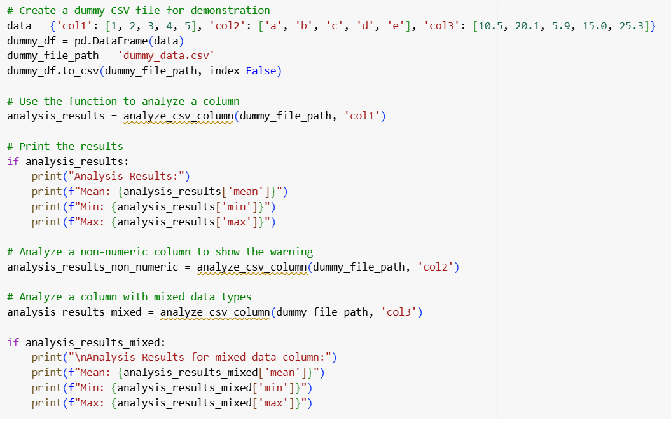

OUTPUT:

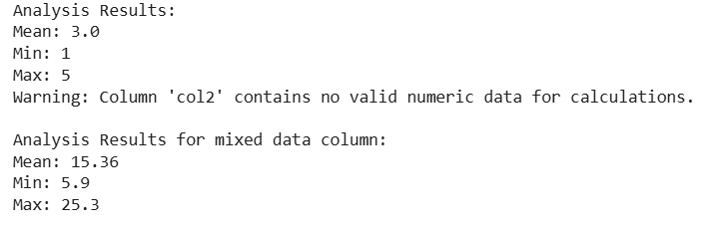

**TASK-2:**

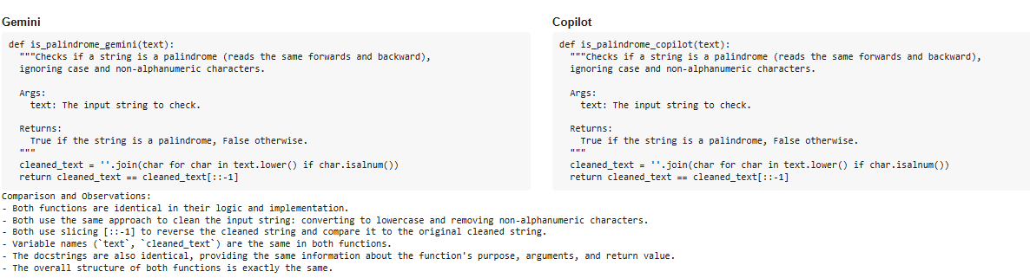

**TASK-3:**

CODE:

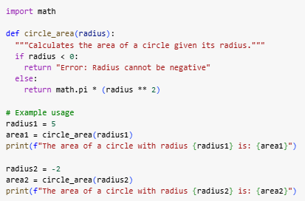

OUTPUT:



**TASK-4:**

PROMPT:

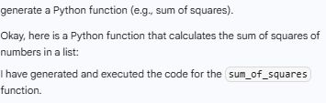

CODE:

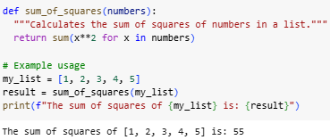

**TASK-5:**

CODE & OUTPUT:

